# Toy Cars

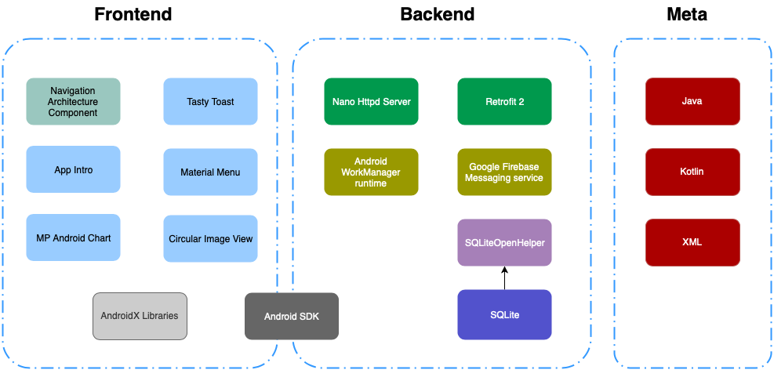

Figure : Stack Diagram of Core Android Application Components

## General:

The application is written in Java and Kotlin using Android SDK in Android Studio IDE. The views are designed using XML-based files and the contents are managed through Java and Kotlin code. The minimum OS version required to run the application is Android 4.2.

The application uses core Android Application framework capabilities to manage the backend and frontend tasks.

## Backend:

[***Nano Httpd* Server**](http://nanohttpd.org/)**:** Used to run an HTTP server on the Android device in order to receive the data from ESP8266 on the toy cars via Wi-Fi.

**SQLite database & SQLiteOpenHelper:** SQLiteOpenHelper library which is part of Android SDK is used to store the incoming data from ESP8266 combined with the current user profile data to the SQLite database.

***Android WorkManager Runtime*:** As soon as a data capture session ends, a query is performed on the database and all of the data not synchronized to the cloud are scheduled to be uploaded as soon as the device is connected to the internet. Android work manager runtime library provided as part of Android architecture components is used to schedule the upload task.

[***Retrofit 2***](https://square.github.io/retrofit/): Used for uploading the JSON encoded data to the cloud. The uploading of the data is currently implemented in the application and it will be functional upon availability of the cloud API to upload the data.

***Google Firebase Messaging service:*** The application is able to receive notifications from the cloud server using Google firebase messaging service which is implemented in the application but not tested yet.

## Frontend:

The frontend of the application uses a limited number of third-party libraries in addition to the native libraries of AndroidX and official Android UI guidelines to deliver a user-friendly interface.

***Navigation Architecture Component***: The majority of navigation view is implemented and managed by navigation architecture component library provided as part of Android Jetpack suit.

[***App Intro***](https://github.com/AppIntro/AppIntro)***:*** This third-part library is used to provide the user guide and information about the application. The guide needs further content and art revisions.

[***MP Android Chart***](https://github.com/PhilJay/MPAndroidChart)***:***  Used to depict the incoming data from ESP8266 in a linear chart to the users.

The application uses other widely used AndroidX libraries such as recycler view in addition to [Tasty Toast](https://github.com/yadav-rahul/TastyToast), [Circular Image View](https://github.com/lopspower/CircularImageView), and [Material Menu](https://github.com/balysv/material-menu) libraries in order to enhance the user experience and interface of the application.

All libraries used in this application are distributed as open source projects on the internet.